**Backend Interface Specification**

Easytodo

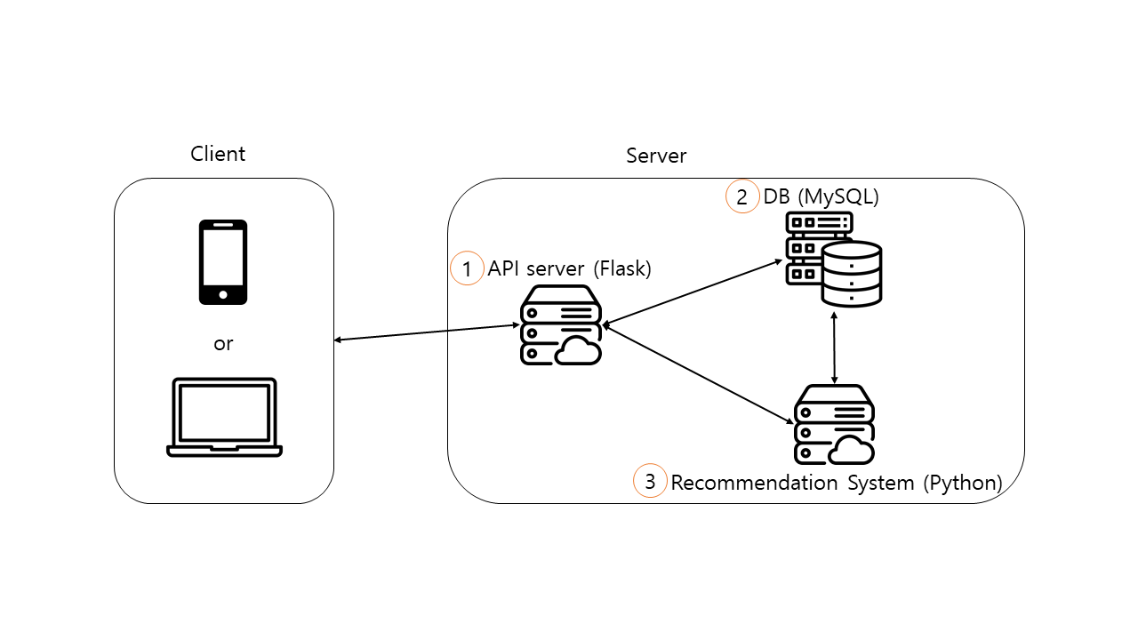

1. API server (Flask)
   1. Input
      1. API -> Client (communication method: REST -> JSON)
         1. POST login
         2. GET userdata
         3. POST update
   2. Output
      1. API -> DB (communication method: SQL query -> data)
         1. SELECT/INSERT/UPDATE
      2. API -> Recomm (communication method: strings through socket)
         1. Get recommendation
2. DB (MySQL)
   1. Input
      1. API -> DB (communication method: REST -> JSON)
         1. SELECT/INSERT/UPDATE
      2. Recomm -> DB (communication method: SQL query -> data)
         1. SELECT
3. Recommendation System (Python)
   1. Input
      1. API -> Recomm (communication method: strings through socket)
         1. Get recommendation
   2. Output
      1. Recomm -> DB (communication method: SQL query -> data)
         1. SELECT